Tick[√] the correct question for each answer. Sometimes both are correct.

1 √ What’s your new job like? It’s great.

__ How’s your new job?

2 _X What’s Edinburgh like? It’s a beautiful city with a castle.

__ How’s Edinburgh?

3 __ What was John like? Great. He looked much better.

_X_ How was John?

4 _X_ What was your meal like? Fantastic. The best fish I’ve ever had.

__ Do you like this meal?

5 __ What do you feel like? Not so good, actually.

_X_ How do you feel?

6 _X_ How old is he? He is 40.

___ How is he?

7 ___How is this room like? About 82 square metres.

_X__ How big is this room?

8 ___ What does Ann wear? Quite smart. She is not keen on informal

clothes.

_X__ What kind of clothes does Ann wear?

___ What does Ann look like?

9. _X__What is this laptop made of? Japan

___Where is this laptop from?

10 X What sort of pasta would you like? I’d like some cereal pasta, please.

___ Do you like cereal pasta?

___What’s this pasta like?

11. ___ What do you look like? I am a bit like my mum.

_X__Who do you take after?

___ What do you like doing?

**Doplň: size, does, many, far…**

1. What …size…boots do you wear. 37
2. How …many……….. cars have you got? 2. Mercedes and Audi
3. How …far………. is your house from the school? A ten-minute walk.
4. How much …does………. is weight? 1 kilo.

**Very important words**:

World-famous , old-fashioned, long-lasting friendship, good-looking, full –time /part-time job, drive carefully, walk slowly/quickly, explain clearly, love passionately, rain heavily, whisper softly, wait patiently, shine brightly

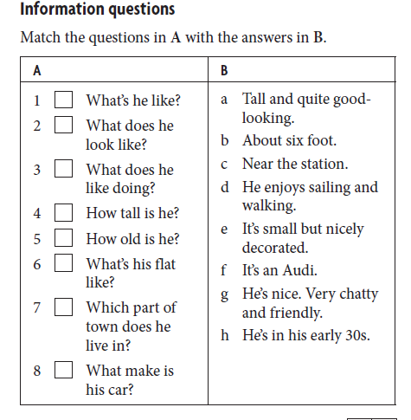

1g, 2a, 3d, 4b, 5h, 6e, 7c, 8f

**Choose the correct words**.

**Example**

I thought his latest book was quite *disappointed* ***/ disappointing***.

1 I do yoga every day. It makes me very ***relaxing / relaxed*.**

2 It’s been raining ***heavily / badly***all day.

3 I enjoy cycling but I find it very ***tired / tiring*.**

4 She’s only four but she can read very ***well / good*.**

5 I never eat ***fast / quick***food.

6 What went ***wrongly / wrong*** with the recipe?

7 You’ll need to work ***hardly / hard***in the weeks before your exams.

8 I bought some lovely ***home-made / hand-made*** jewellery in Mexico.

9 I’m feeling ***exhausted/exhausting.*** This test was very difficult.

10. She is ***relaxing/relaxed*** because the massage was ***relaxing/relaxed.***

11. I am **charmed** because I have a ***charming/charmed*** classmate.

12. My sister is ***interesting/interested*** in reading books.

13. This movie was ***disappointed/disappointing***.

**Adjectives**

1. My kids are ...well.......-behaved. They are always so nice.
2. Your kids are ..badly.....-behaved. They are always so rude.
3. He is so ..hard....... – working. He always works in his garage or in the garden.
4. This decoration is ....hand........-made.
5. This pizza is ...home..- made.
6. First-..born........children are more responsible.

**Choose the most suitable word:**

1. Eat a lot of ***fresh /brand-new /latest*** fruit.
2. In Gelnica we have ***old-fashioned / ancient /traditional*** ruins**.**
3. She is tall, blonde and ***handsome / pretty / nice.***

**Add *–ly/-* if necessary:**

1. I dress bad_ly__
2. Try to explain it clear_ly___
3. He sudden_ly__ came.
4. He studies hard__-___
5. Go straight_-___!
6. Walk slow_ly___!
7. I almost_-___ fell.
8. Have you finished? Almost_-___. Give me 5 minutes.
9. He drives very fast -_____.

**Answer key:**

Tick: 1.1, 2.1, 3.2, 4.1, 5.2, 6.1, 7.2, 8.2, 9.2, 10.1, 11.2

Doplň: Size, many, far, does

Information questions: 1g, 2a, 3d, 4b, 5h, 6e, 7c, 8f

**Adjectives:** well, badly, hard, hand, born

Choose the most suitable word: fresh, ancient, pretty

Add -ly if necessary: badly, clearlym suddenly, hard, straight, slowly, almost, almost, fast.